Name: ___________________
UNIT 2
FOOD- HOW DO YOU ANSWER THE QUESTION?
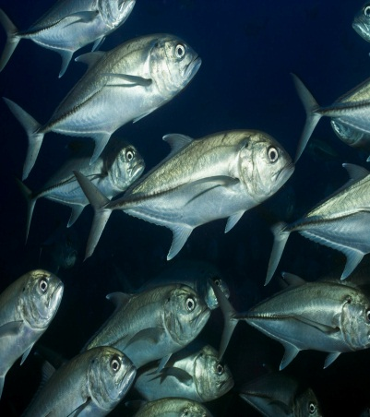
Essay Planning and Writing
- _____ 20 pts. 11/4-5 10. _____ 30 pts. 12/1-2
- _____ 50 pts. 12/1 Extra Credit: ______
- _____ 30 pts. 12/1
- _____ 50 pts. 7. _____ Video Scaffolding Grade 11/12-21
- _____ 30 pts. 1/26-28 9. _____ Rough Draft Grade 1/12-16
- _____ 30 pts. 1/6-7 11._____ Book Deconstruction Grade 12/3
- _____ 30 pts. 12. _____ Essay Grade 1/21-23
Message to the Instructor: ___________________________________________
Items 1, 2, 3, 4, 5, 6, 7, 8, and 10 are graded as the research and reading unit and will compose one grade.
270 pts. X .37 = ______ Research and Reading Grade 1/12
Items 9, 11, and 12 will all be separate grades and count equally with the Research and Reading Grade.
- Video: Food Inc. – 2 days (94 minutes) The students will watch the video and discuss questions to be answered for research. Each student must submit five questions. 20 pts. (3)
- Books. The student will finish the book started during Unit 1. The student will continue to highlight and note take. The student needs to write at least 10 notes per chapter and 10 highlights per chapter. If the student is using the text the student needs to tab 10 places in each chapter and list ten facts per chapter. 50 pts. (10)
- Book Test. The student will take a test on the book they are reading. 30 pts.
- Videos. The student will select five videos on the research topic they selected. Write the URL and then a one paragraph summary of each video. Select the best video and deconstruct this one. List the thesis or question. List three reasons given by the author. List the conclusion. Include the counterargument if there is one. 50 pts. (3)
- Deconstruction of Bird Article. Everyone will read the article and with a partner deconstruct the article using the deconstruction rubric to deconstruct it. Then they will use the criteria of credibility to validate the author and magazine. When they complete their findings one group will present their deconstruction findings and lead a discussion on the topic. Then another group will present their raven findings and lead a discussion on the topic. Everyone else will add their findings and we will come to a consensus on the article. 30 pts. (Presenting groups receive 20 extra credit points.) (5)
- Video and Creating Questions. Watch the video What’s Wrong with What we Eat? Matt Bittman TED lecture
The students will create questions from the video. Students will form a team of four students and each student will submit five questions to the group and the group will select five and refine their questions. Each group will select the best three questions from the video. If the group gets a question selected they receive 20 extra points. 30 pts. (2)
- Video. Fast Food Nation (116 minutes) – 3 day After watching the video the students will discuss labor and agribusinesses and immigration. Students will select a partner and form a thesis, 4 reasons to support the argument, use three additional sources, validate all three sources, reflect on the topic, and write a conclusion. This is not formal essay but a scaffolding exercise. When the partners are finished they will trade with another group and the 2nd group will peer review the 1st group. 100 pts. (70 pts. for the scaffolding and 30 pts. for the peer review) (8)
- Global Perspective. Select four examples from other places that illustrate the global nature of the issue. These examples need to be placed as raw material and cited. 30 pts. (2)
- Rough Draft for Essay. The student will create a rough draft for the essay with references. This will not be in essay format but the materials in place without analysis and connective tissue. 100 pts. (5)
- Book Discussion. The students will take part in a 2 day book discussion. They should have materials with them and speak at least five times. 30 pts.
- Book Deconstruction. The student must have the following items: thesis and counter thesis, if any, five questions from the book, twenty facts with page numbers, a raven exercise of the author, 10 postings on social media, and 5 reasons the author gives to support the thesis. 100 pts. (1)
- Essay. The student will write a 1700 to 2000 word essay on their question. The student will write the essay at home but can receive assistance from the instructor during the process. Do not wait to the last minute. The student must submit the essay to two other students who must peer review the essay. The peer review must be submitted with the final essay. Essay 80 pts. and Peer Review is worth 20 points. (3)

